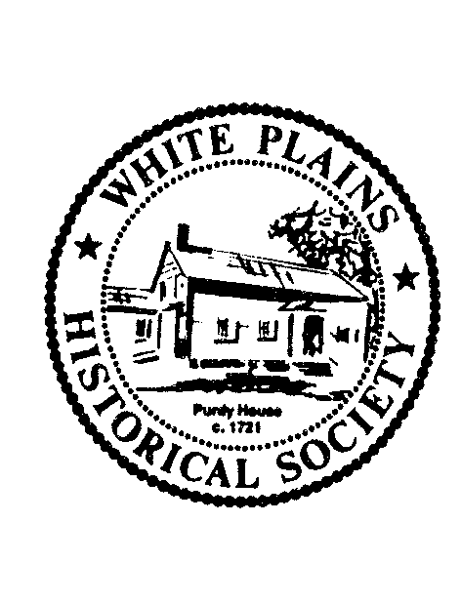
White Plains Historical Society
21st Annual Dinner Program
Welcome
Robert Hoch, President

Revolutionary Honor Guard
Led by Denis Jones, Trustee

Pledge of Allegiance
Led by Bruce Handler, Trustee

National Anthem

Installation of Trustees
Patti Indelicato, Trustee

Grace
(Dinner is served)

Presentation
Tribute to Excellence in Historic Preservation
to
Walter Handelman, Alice Model and the James A. Macdonald Foundation
Presented by Robert Hoch – Comments by William Miller

Citizen Extraordinaire Award
to
Riena Kaplow
Presented by Hon. Robert J. Friedman, Past President

Key Note Address
“When Artwork Speaks, Eyewitness Images from the American Revolution”
Arthur S. Lefkowitz
Introduction by John Vorperian

Flowers Provided by Amodio’s Garden Center, Nursery and Flower Shop

